**Homework 3**Lesson: Efficient Frontier Stock ValuationStudent Name: Zhao EnpingClass: G1

**Part 1**

Create a table showing the performance metrics for the ten industry portfolios. Also plot your results as a bar chart for each performance metric. Briefly explain the economic significance of each performance metric.

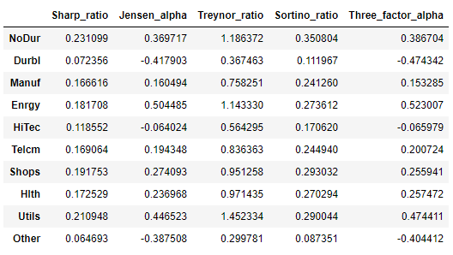

|  |  |
| --- | --- |
| **Economic Significance** | **Bar Plot of Performance Matrix of 10 Industries** |
| **Sharpe ratio** is risk premium per unit of standard deviation. The greater a portfolio's Sharpe ratio, the better its risk-adjusted-performance Is. Therefore, investor should invest in portfolio that has higher Sharpe Ratio. The Sharpe ratio is also often used to compare the change in overall risk-return characteristics when a new asset or asset class is added to a portfolio. If the addition of the new investment lowered the Sharpe ratio, it should not be added to the portfolio. |  |
| **Jensen's alpha** is intercept coefficient from market model regression using excess returns: If the alpha value is positive, then the portfolio is earning excess returns. In real life, Jensen's alpha is also used to measure the performance of a portfolio manager, if Jensen's alpha is positive, it means that the fund manager has "beat the market" with their stock-picking skills. |  |
| **Economic Significance** | **Bar Plot of Performance Matrix of 10 Industries** |
| **Treynor ratio** is risk premium per unit of market risk. the Treynor ratio attempts to measure how successful an investment is in providing compensation to investors for taking on investment risk. The difference Sharpe Ratio and Treynor Ratio is that the Treynor ratio utilizes a portfolio beta (the sensitivity of the portfolio's returns to movements in the market), or systematic risk, to measure volatility instead of adjusting portfolio returns using the portfolio's standard deviation as done with the Sharpe ratio. |  |
| **Sortino ratio** is expected deviation from target (or benchmark) return, per unit of below-target semi-deviation. The Sortino ratio is a useful way for investors to evaluate an investment's return for a given level of downside risk. Since this ratio uses only the downside deviation as its risk measure, it addresses the problem of using total risk, or standard deviation, which is important because upside volatility is beneficial to investors and isn't a factor most investors worry about. |  |
| **Three Factor Alpha** is the intercept coefficient from Fama–French three-factor model. The Three Factor Alpha is similar to the use of Jensen's alpha, the difference is that the Fama–French model has added two more factors (profitability and investment) to the model and investor should look for portfolio that has positive alpha for investment. |  |

**Part 2**

Using Monte Carlo simulation Plot the points with mean return on the vertical axis and standard deviation of return on the horizontal axis to show the minimum-variance frontier.

**a)**

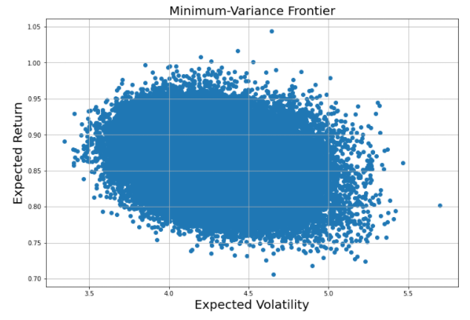

**b)**

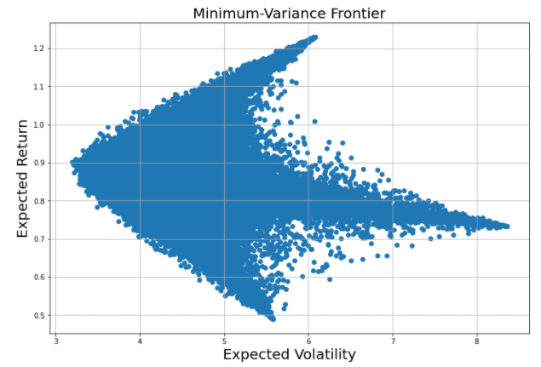

**Appendix:**

